Chapter 11, Problem 97.

A power transmission system is modeled as shown in Fig. 11.99. If V_{s} = 240 ∠0° V rms, find the average power absorbed by the load.

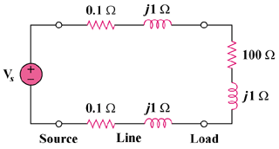

Figure 11.99
For Prob, 11.97.

